Concept Generation

**Main areas of focus for concept generation**

* Heel Mechanism
* Changeable angle of inclination
* Changeable exterior fabric around ball of fool

**Heel Mechanism**

1. Origami Design Concept

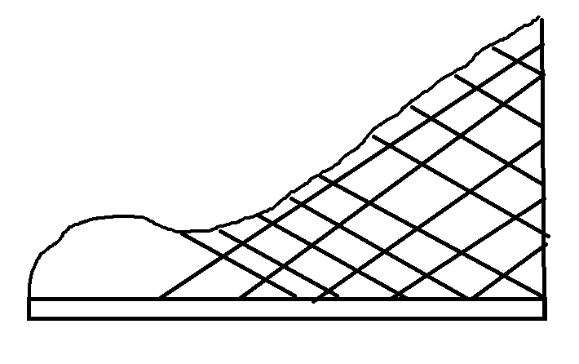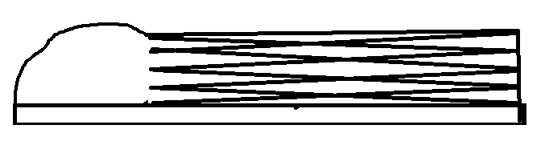

Figure 1: Left image is elevated state, right image is folded/flat state

This concept uses an origami lattice structure to fold down. A benefit would be the unique design could be very stylish. This concept would only work with a wedge heel. This design does not have any removable parts. The specific origami lattice structure has not been developed but we believe it to be a feasible design.

2. Telescoping Heel

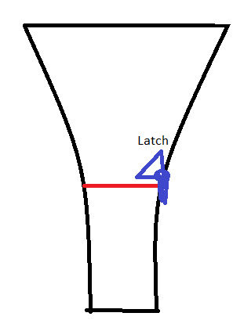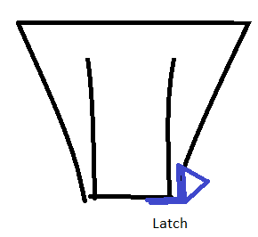

Figure 2: Left image is extended heel, right image is rescinded heel

The heel extended and retracts into itself, a latch is used to secure the heel in either the extended or rescinded position. This design would only allow for a small heel high on the flat state instead of a completely flat shoe. This design does not have any removable parts. The design uses a telescoping mechanism in order to go up into the upper part of the heel.

3. Folding Heel Concept 1

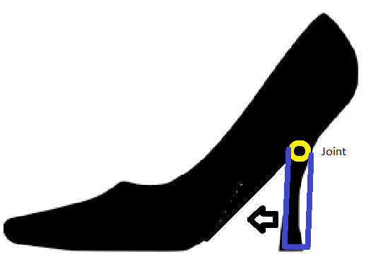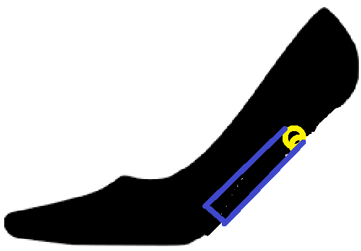

Figure 3: Right image is extended heel, right image is folded heel

This concept has a hinge or joint at the top of the heel that allows the heel to pivot. When folded down, the heel goes into the bottom of the shoe and turns into a flat. The bottom of the shoe would have to have some thickness in order to accommodate the heel fitting inside of it. This design is probably the simplest to implement. This design does not have any removable parts.

4. 3 Bar Mechanism

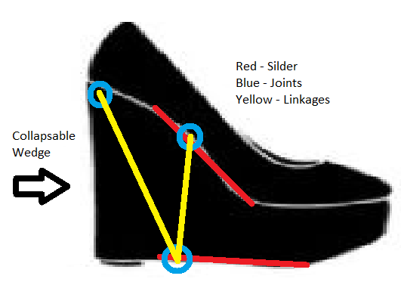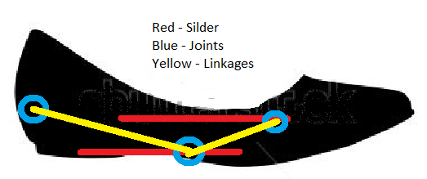

Figure 4: Left image is elevated state, right image is folded/flat state

This concept uses a three bar mechanism with two sliders. The joints are illustrated with circles. The left joint is fixed at the back of the shoe, the middle joint is on a slider attached to the bottom of the shoe and can move forward and backward. The right joint is attached to the slider on the bottom of the moving insole. A latching mechanism would be installed to keep the shoe in an elevated or flat state. The left and right joints would be used to support the heel and the middle of the foot respectively. This design does not have any removable parts.

5. Folding Heel Concept 2

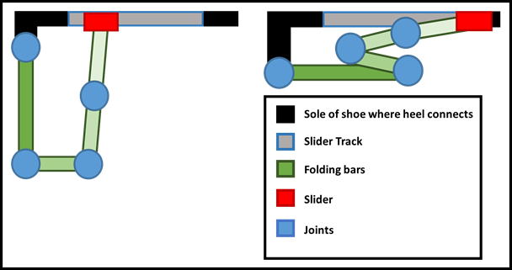

Figure 5: Folding Heel Concept

The idea behind this concept is to make the heel a simple four to five bar mechanism (A rough diagram of an example like is pictured above. The heel would simply fold in on itself. The mechanism could potentially be difficult to make stylish of hide. The mechanism may also take up more space than desired. Benefits would be the simplicity of design and ease of transitioning between states.

6. Hug Slide Heel Concept

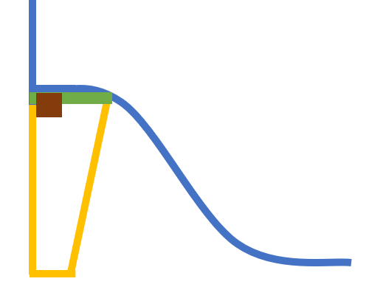



Figure 6: Hug Slide Heel Concept

This concept has the heel as a hollow structure. Three “plates” connect to form a triangular heel. The one connection can be unclasped and the plates unfolded. The unfolded plates could then be slid up the back of the shoe making the heel disappear. The benefit of this design is that it would allow us to make the heel go completely away giving us a truly flat shoe. The downsides is that the heel height is limited to the height of the back side of the shoe. Concerns about comfort and style with this design are also present.

7. Slide Swivel Heel Concept

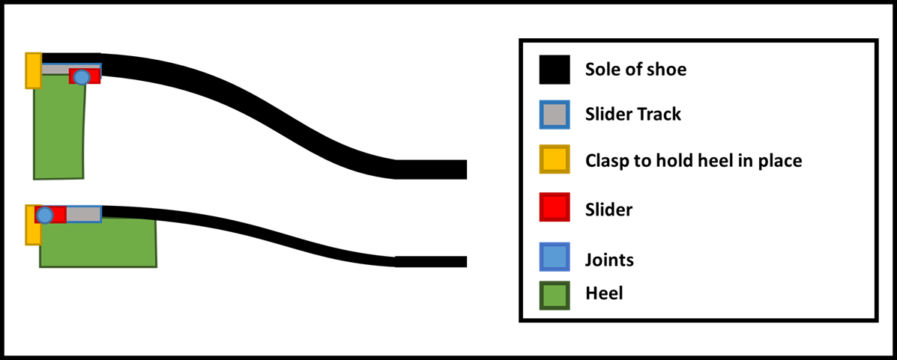

Figure 7: Slide swivel heel concept

This concept would make the heel one “block” the would slide backwards and rotate to essentially transition from a standard high heel to a short wedge heel. Concerns with this design is its potentially bulky nature making it take up too much space and be difficult to make fashionable. Benefits would be ease of transitioning between states. Depending on other design choices, the heel supporting the sole of the shoe in its flat state may be helpful as well.

8. Removable Heel Concept

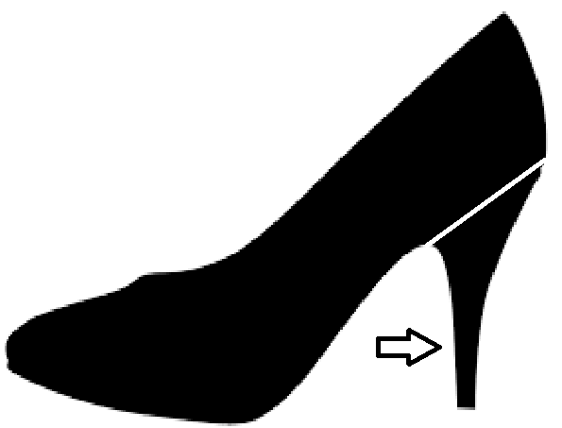

Figure 8: Removable Heel Concept

This heel is a simpler design with a slider that allows the heel to slide in and out. This design would allow for the most versatility as the heel could be interchanged for different colors, heights, and styles. The major downside would be the removable part is not desired by users at it would require them to hold on to and not lose the removable heel.

**Changeable angle of inclination**

1. Bottom of insole flexibility concept

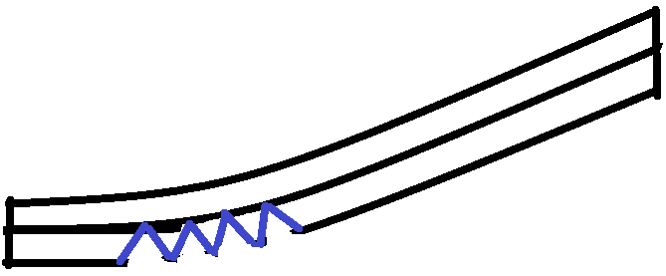

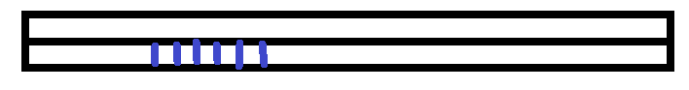

Figure 8: Top image is elevated state, bottom image is flat state

Description, Pros, Cons:

2. Top of insole flexibility concept



**Figure 9.** Image of shoe in its flat state.



**Figure 10.** Image of shoe in its elevated state.

This concept is inspired by vertebrae in the human body. While the shoe is in its flat state the “vertebrae” are in a state of tension. When the shoe is in its elevated state the vertebrae compress together to provide stability for the heel wearer. Benefits include accommodation for the angle change while in an elevated state. Potential cons include possible loading constraints and difficulties with material selection. The material selected for the outer sole of the shoe needs to be flexible enough to bend at the arch and rigid enough to support the user’s body during use.

**Changeable exterior fabric around ball of fool**

1. Separate fabric at joint so that the sides are allowed to move freely

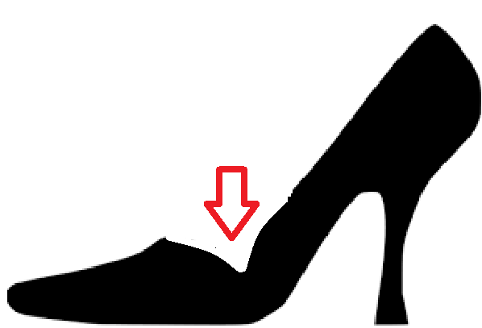

Figure 11: Separated side fabric concept

The fabric along the sides of the heel would buckle when converting from a flat position to an elevated position. In order to fix this issue, the fabric at the joint could come down to the insole and then back up to the fabric. This would fix the buckling that occurs at the changing joint.